Science conference webpage

AIM : Create html web page for advertising about Science Symposium/Conference that is yet to happen in your department.

* Your web page should display at least best technical science project videos that was presented in last year.
* Make videos to scroll in your web page.
* Mention the Event name, Event date, Project submission deadlines, Abstract Submission and payment details of conference/event in detail. Use Bookmark link to move to different parts of same page.
* You can also add audio link if required in your web page.
* Use iframes and basic formatting tags and add more creativity to your web page.

HTML TAGS USED IN THIS WEB PAGE :

* <html> - Starting to any html document
* <head> - Heading content of the html file
* <title> - To specify the heading of the page
* <body> - Body content of the html file
* <link> - To link CSS file
* <div> - To create a division like a separate container
* <img> - To link an image into the website
* <a> - To link any webpage bookmarks
* <marquee> - To Scroll text in a webpage
* <centre> - To place content in the tag in centre padding
* <pre> - To display content on the web page as-it-is typed in document
* <br> - breaking line and print on next line
* <hx> - heading tag followed by a number noting its size
* <header> - To specify main headings
* <p> - Paragraph tag for text
* <audio> - To insert audio files into the webpage
* <source> - To specify the audio file location
* <iframe> - To Insert any youtube or video from internet

HTML CODE FOR MAIN WEB PAGE :

<!DOCTYPE html>

<html lang="en">

<head>

<meta charset="UTF-8">

<meta http-equiv="X-UA-Compatible" content="IE=edge">

<meta name="viewport" content="width=device-width, initial-scale=1.0">

<title>Science Projects</title>

<link rel="stylesheet" href="style.css">

</head>

<body>

<div class="header">

<img src="logo.png" alt="" srcset="">

<h1>SCIENCE AROUND US ...</h1> <br>

<div class="list">

<a href="#about" >Home</a>

<a href="projects.html" target="_blank">Projects</a>

<a href="videos.html" target="_blank">Videos</a>

<a href="#">Contact us</a></div>

</div>

<h1><marquee>where innovative minds compete together....</marquee></h1>

<center><img src="artificial.jpg" width="80%" height="300px"></center>

<div class="about" id="about">

<center>

<h2>What is machine learning?</h2>

<pre style="font-family: 'Gill Sans', 'Gill Sans MT', Calibri, 'Trebuchet MS', sans-serif;">

Machine learning is the science of getting computers to act without being explicitly programmed

In the past decade, machine learning has given us self-driving cars, practical speech recognition, effective web search,

and a vastly improved understanding of the human genome.

Machine learning is so pervasive today that you probably use it dozens of times a day without knowing it.

Many researchers also think it is the best way to make progress towards human-level AI..

</pre>

<h2>Significance of Machine learning</h2>

<pre style="font-family: 'Gill Sans', 'Gill Sans MT', Calibri, 'Trebuchet MS', sans-serif;">

Predictive modeling and machine learning algorithms can help simplify a company’s documentation process,

eliminating the risks associated with manual data entry. The formula can be used to automate the data entry

process and ultimately allow specialized resources to focus on important and creative tasks.

</pre>

</center>

</div>

<br><br><br>

<center>

<hr>

<h1><a href="#E1" style="color: orange;">click here to check Event Timeline</a></h1>

</center>

<br><br>

<img src="mlearn.jpeg" width="40%" height="70%" align="right">

<div class="details">

<h3 style="text-decoration: underline;">Event: </h3>

<pre>

PROJETCS ON MACHINE LEARNING

Starts on: april 8th,2022

</pre>

<br>

<h3 style="text-decoration: underline;">Project Submission deadline : </h3>

<pre>

april 10th,2022(to get approval)

</pre>

<img src="bbrain.jpg" width="40%" height="30%" align="right" >

<br>

<h3 style="text-decoration: underline;">Regestration fee : </h3>

<pre>

250/- per student.

</pre>

<br>

<h3 id="E1" style="text-decoration: underline;">Event Timeline : </h3>

<pre>

Event inauguration: april 7th,2022.

Event occurs: april 8th,9th,10th 2022.

day:1 -> students of CSE department.

day:2 -> students of to AI department.

day:3 -> student of Cyber security department.

day:5 -> announcement of winners.

</pre>

</div>

<br><br><br>

<center>

<h1>A glimpse on what is machine learning</h1>

<audio controls>

<source src="audio.mp3">

</audio>

<br>

<iframe width="560" height="315" src="https://www.youtube.com/embed/f_uwKZIAeM0" title="YouTube video player" frameborder="0" allow="accelerometer; autoplay; clipboard-write; encrypted-media; gyroscope; picture-in-picture" allowfullscreen></iframe>

</center>

<br><br><br>

</body>

</html>

CSS CODE FOR Main Site :

body{

background-size:cover;

background: linear-gradient(-45deg, #d9a7c7, #eca9d4, #e7e2b4, #fffcdc);

background-size: 400% 400%;

animation: gradient 9s ease infinite;

height: 100vh;

}

@keyframes gradient {

0% {

background-position: 0% 50%;

}

50% {

background-position: 100% 50%;

}

100% {

background-position: 0% 50%;

}

}

.header{

display: grid;

grid-template-columns: .1fr 1fr .2fr 1fr;

}

.header img{

width: 100%;

padding-top: 14px;

}

.header .list{

padding-top: 30px;

font-size: 25px;

display: grid;

grid-template-columns: 1fr 1fr 1fr 1fr;

}

.header .list a{

text-decoration: none;

color: black;

}

.header .list a:hover{

font-size: 120%;

text-decoration: underline;

color: red;

}

marquee{

font-size: 20px;

color:orangered;

}

h1{

color:red;

}

.details{

font-size: 25px;

font-family: Verdana, Geneva, Tahoma, sans-serif;

color:black;

}

h2{

color: yellow;

font-size: 50px;

}

.about{

font-size: 20px;

color: black;

font-family:Cambria, Cochin, Georgia, Times, 'Times New Roman', serif;

}

SCREENSHOTS :

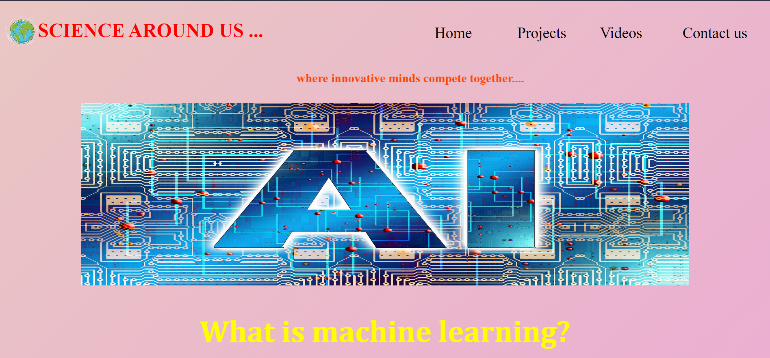

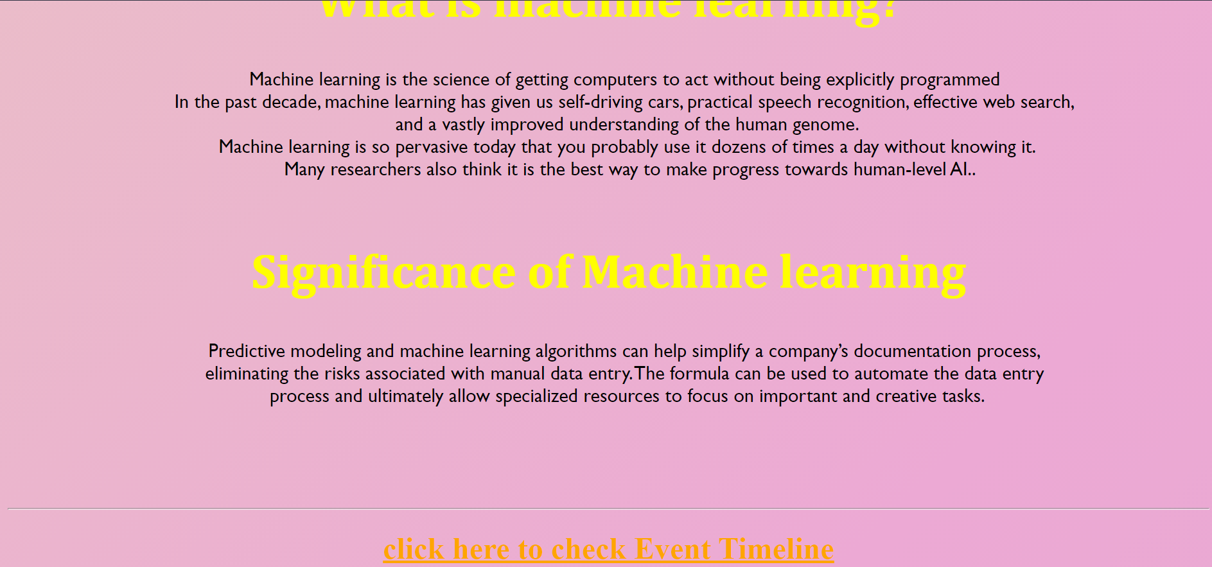

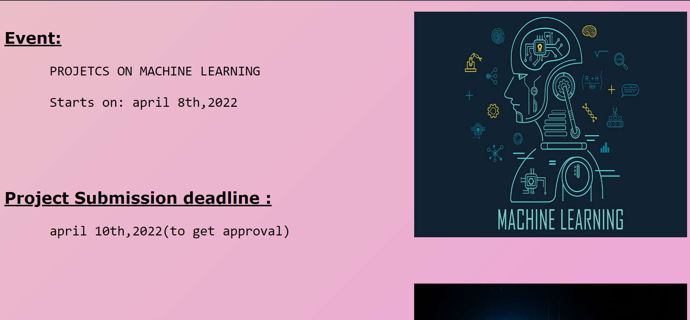

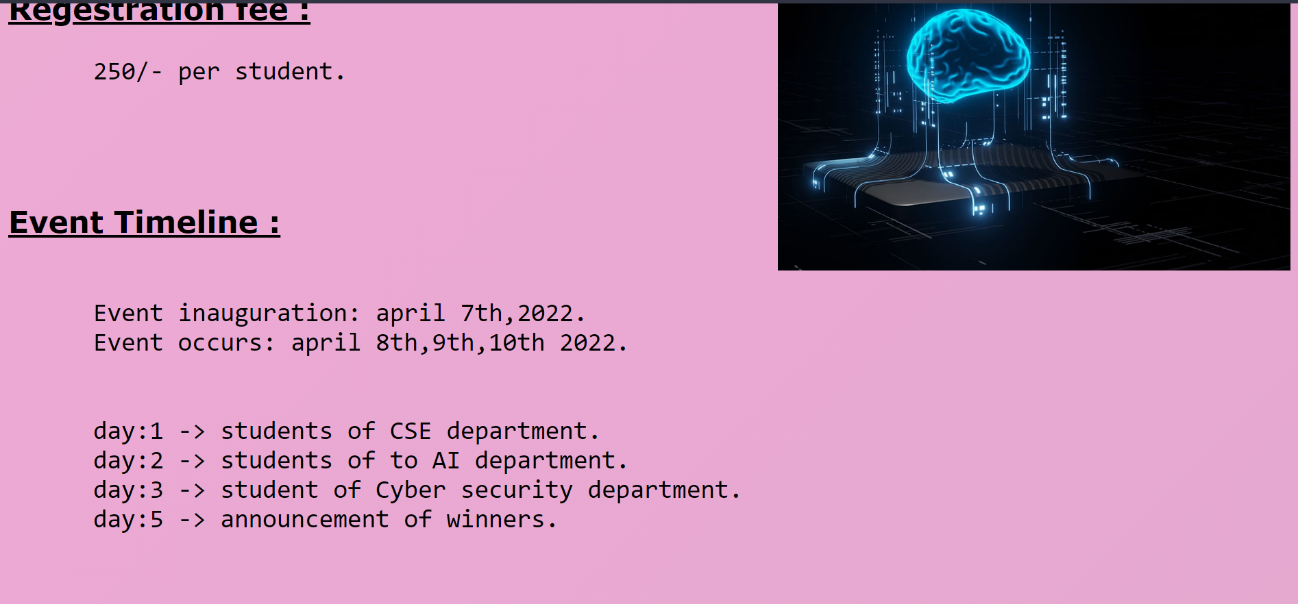

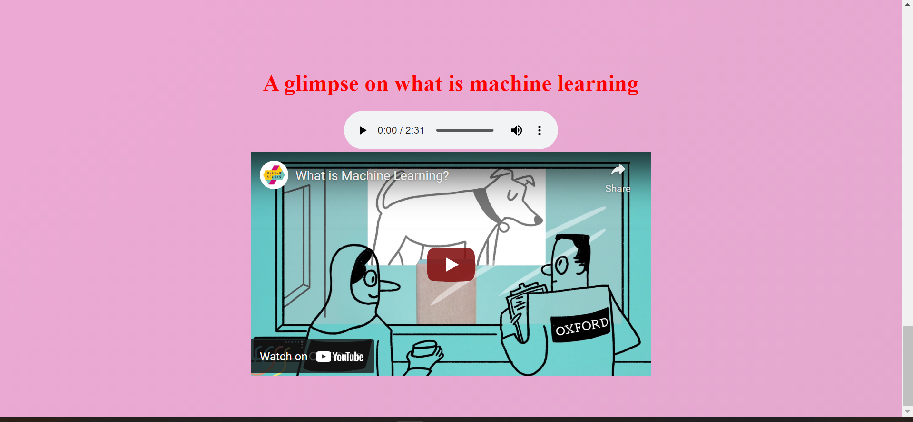

Project PAGE SOURCE:

<!DOCTYPE html>

<html>

</html>

<head>

<title>list of projects on machine learning</title>

</head>

<style>

body{

background-size:cover;

background: linear-gradient(-45deg, #d9a7c7, #eca9d4, #e7e2b4, #fffcdc);

background-size: 400% 400%;

animation: gradient 9s ease infinite;

height: 100vh;

}

@keyframes gradient {

0% {

background-position: 0% 50%;

}

50% {

background-position: 100% 50%;

}

100% {

background-position: 0% 50%;

}

}

h1{

font-family: 'Franklin Gothic Medium', 'Arial Narrow', Arial, sans-serif;

color:red;

font-size: 50px;

}

.pic2{

text-align: end;

}

a:link{

color:orangered;

font-size: 30px;

}

.home{

color: brown;

}

a:visited{

color:blue;

}

</style>

<h3><a target="_blank"; href="index.html">Home</a></h3>

<center><h1> ML real-time projects<h1></h1>

</center>

<center><img src="aml.png" width="70%" height="300px"></center>

<center>

<a target="_blank"; href="https://github.com/ashishpatel26/500-AI-Machine-learning-Deep-learning-Computer-vision-NLP-Projects-with-code">click here to explore with some source codes and more ideas about ML</a>

</center>

<br><br><br>

</body>

SCREENSHOTS :

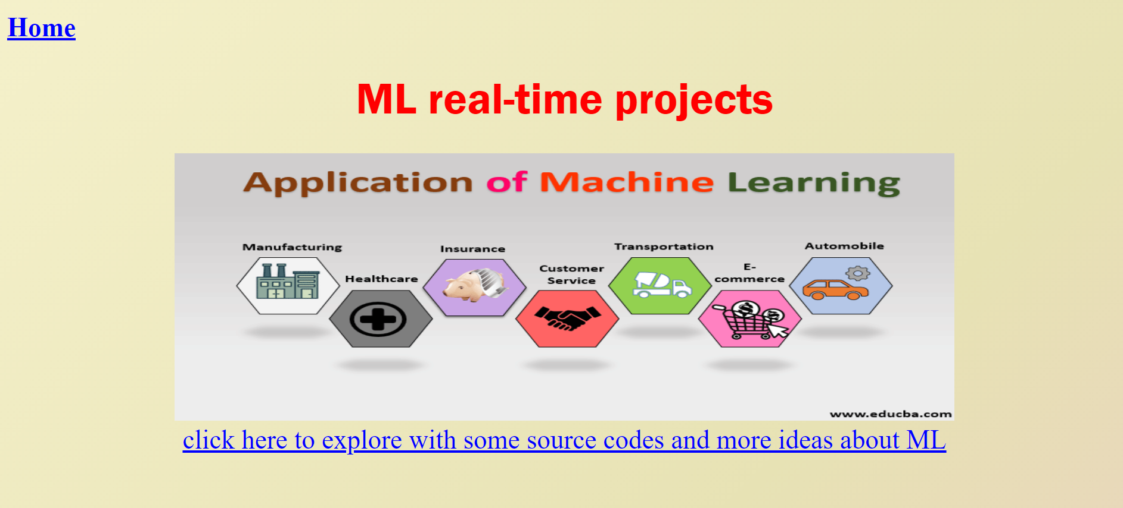

Videos PAGE SOURCE:

<!doctype html>

<html>

<head>

<title>videos</title>

</head>

<style>

header{

color:blue;

text-align: center;

font-family: 'Trebuchet MS', 'Lucida Sans Unicode', 'Lucida Grande', 'Lucida Sans', Arial, sans-serif;

font-size: 30px;

}

body{

background-color: yellowgreen;

background-size: cover;

}

</style>

<body>

<h2><a href="index.html">Go Back</a></h2>

<header>

<h1>

Videos on how we can explore projects on machine learning

</h1>

</header>

<br> <br> <br> <br>

<div class="scroll" >

<marquee behavior="scroll" direction="left">

<iframe width="560" height="315" src="https://www.youtube.com/embed/6u0bW7NTRV0" title="YouTube video player" frameborder="0" allow="accelerometer; autoplay; clipboard-write; encrypted-media; gyroscope; picture-in-picture" allowfullscreen></iframe>

<iframe width="560" height="315" src="https://www.youtube.com/embed/BOhgGA7Eu5E" title="YouTube video player" frameborder="0" allow="accelerometer; autoplay; clipboard-write; encrypted-media; gyroscope; picture-in-picture" allowfullscreen></iframe>

<iframe width="560" height="315" src="https://www.youtube.com/embed/nKW8Ndu7Mjw" title="YouTube video player" frameborder="0" allow="accelerometer; autoplay; clipboard-write; encrypted-media; gyroscope; picture-in-picture" allowfullscreen></iframe>

<iframe width="560" height="315" src="https://www.youtube.com/embed/y5nChwC0TTs" title="YouTube video player" frameborder="0" allow="accelerometer; autoplay; clipboard-write; encrypted-media; gyroscope; picture-in-picture" allowfullscreen></iframe>

<iframe width="560" height="315" src="https://www.youtube.com/embed/H9yACitf-KM" title="YouTube video player" frameborder="0" allow="accelerometer; autoplay; clipboard-write; encrypted-media; gyroscope; picture-in-picture" allowfullscreen></iframe>

<iframe width="560" height="315" src="https://www.youtube.com/embed/1eBxt9HUfh8" title="YouTube video player" frameborder="0" allow="accelerometer; autoplay; clipboard-write; encrypted-media; gyroscope; picture-in-picture" allowfullscreen></iframe>

<iframe width="560" height="315" src="https://www.youtube.com/embed/6u0bW7NTRV0" title="YouTube video player" frameborder="0" allow="accelerometer; autoplay; clipboard-write; encrypted-media; gyroscope; picture-in-picture" allowfullscreen></iframe>

<iframe width="560" height="315" src="https://www.youtube.com/embed/BOhgGA7Eu5E" title="YouTube video player" frameborder="0" allow="accelerometer; autoplay; clipboard-write; encrypted-media; gyroscope; picture-in-picture" allowfullscreen></iframe>

<iframe width="560" height="315" src="https://www.youtube.com/embed/nKW8Ndu7Mjw" title="YouTube video player" frameborder="0" allow="accelerometer; autoplay; clipboard-write; encrypted-media; gyroscope; picture-in-picture" allowfullscreen></iframe>

<iframe width="560" height="315" src="https://www.youtube.com/embed/y5nChwC0TTs" title="YouTube video player" frameborder="0" allow="accelerometer; autoplay; clipboard-write; encrypted-media; gyroscope; picture-in-picture" allowfullscreen></iframe>

<iframe width="560" height="315" src="https://www.youtube.com/embed/H9yACitf-KM" title="YouTube video player" frameborder="0" allow="accelerometer; autoplay; clipboard-write; encrypted-media; gyroscope; picture-in-picture" allowfullscreen></iframe>

<iframe width="560" height="315" src="https://www.youtube.com/embed/1eBxt9HUfh8" title="YouTube video player" frameborder="0" allow="accelerometer; autoplay; clipboard-write; encrypted-media; gyroscope; picture-in-picture" allowfullscreen></iframe>

</marquee>

<br><br><br>

</body>

</html>

SCREENSHOTS :

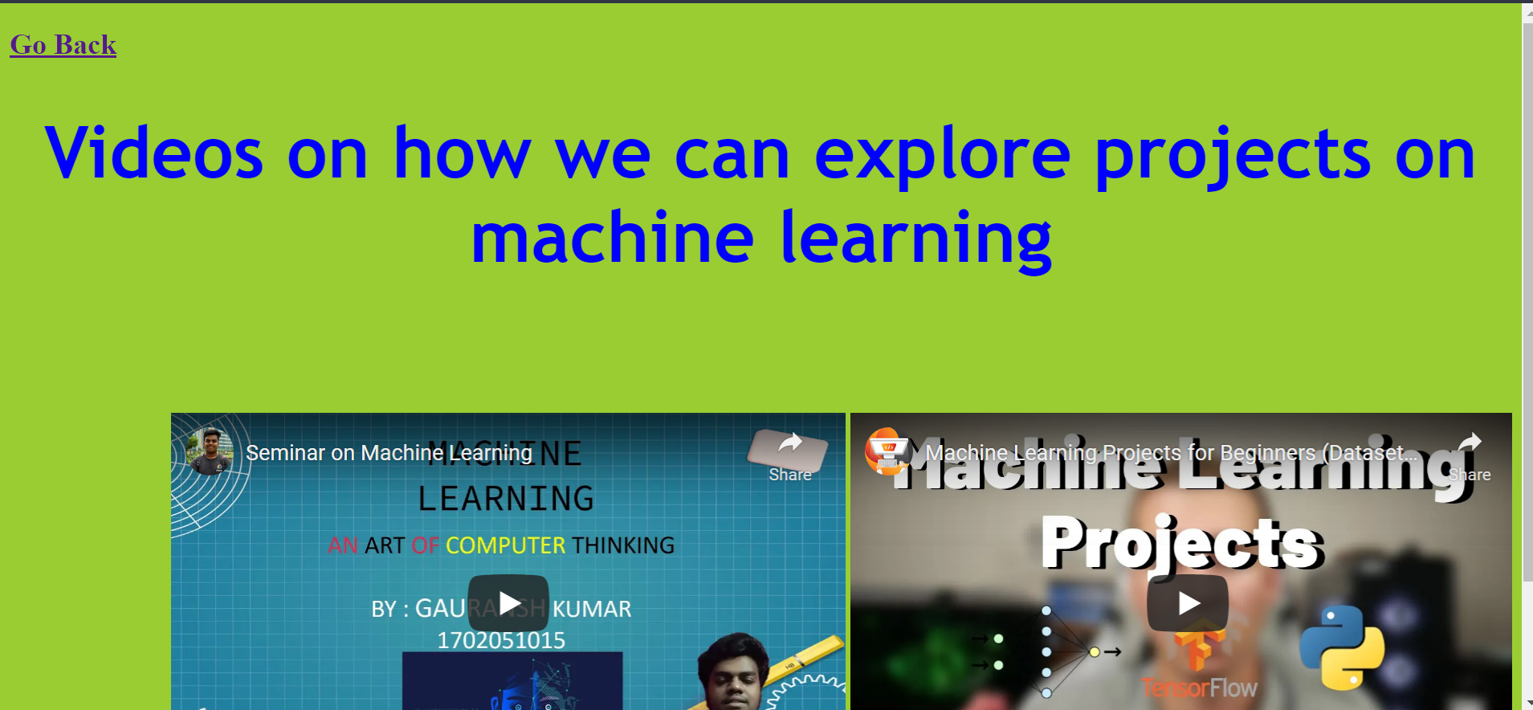

CONCLUSION :

1) We have successfully created a webpage for our upcoming science conference

2) By using various html tags which helped to create

this webpage.

3) Also created Separate projects page along with separate videos page.